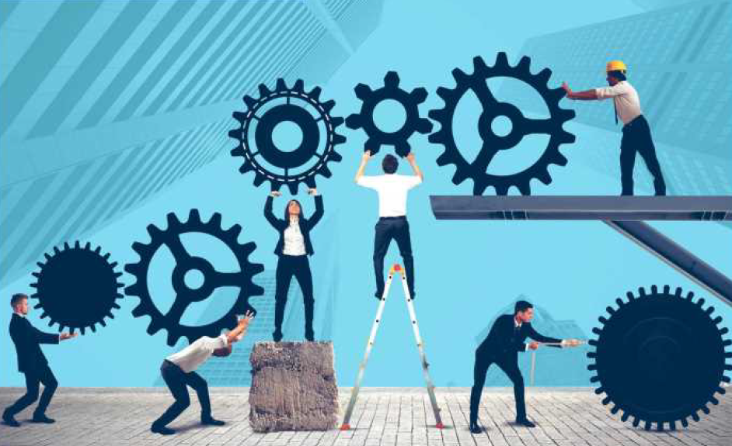
Interactive session on Conducive Startup Ecosystem

Dear Sir/ Madam,

YLF (Young Leaders Forum of IMC), IMC Startup Committee and Millionminds, have joined hands to organise a series of interactive sessions – for the Startup community and contribute to their growth and development. The sessions would deliberate on exchanging ideas between the Established Startups, new & fledgling Startups, the investment community of VC/ Fund Managers and the representatives of regulatory & industry bodies.

First in series is an Interactive session on” Conducive Startup Ecosystem” scheduled on Tuesday, January 28, 2020 at 4.30 pm at Babubhai Chinai Committee Room, 2nd Floor, IMC bldg, Churchgate, Mumbai 400020.

This interactive session will involve two panel discussions with eminent speakers from the industry on:
Panel-1: Challenges for the Startup Ecosystem: Scaling & Talent
Panel-2: CleanTech, AI & Machine Learning

We cordially invite you to attend this interactive session. To register send your confirmation to Dr. Ila Pathak Jha at ila.pathakjha@imcnet.org or call us on+91 22 71226666.

Kindly note there are no registration fees, but registration is MANDATORY due to limited number of seats. We look forward to your participation.

Ajit Mangrulkar
Director General,
IMC Chamber of Commerce and Industry

